July 14, 2022

To Whom This May Concern
(Residents/Realtors of Amador County)

RE: Assembly Bill-38 Home Sale Inspections

The purpose of this notice is to inform the community of Amador County that Amador Fire Protection District is currently not performing defensible space inspection as a result of home sales of a property within our County as outlined in the Assembly Bill 38.

If you need a home inspection, please contact California Department of Forestry and Fire Protection main defensible space phone line at 530-708-2793

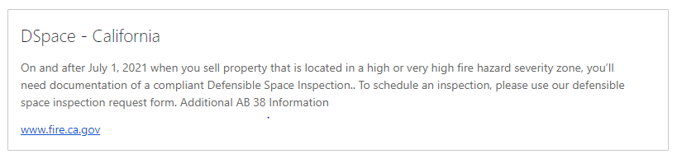

If you have any questions or concerns regarding this letter, feel free to contact me at 209-223-6391. Thank You.

Sincerely,

Patrick Chew, Fire Marshal

